**Question 1**

Notes

* Consider adding look-up entities as CAR_MODEL and CAR_MAKE
* In the Physical Model, think of more relevant attributes

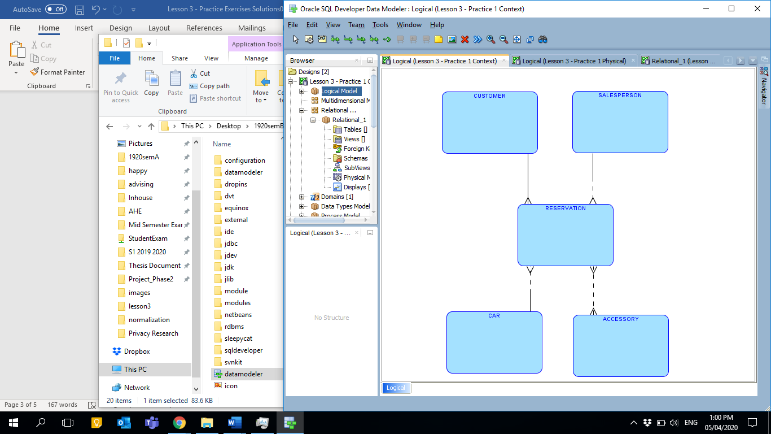

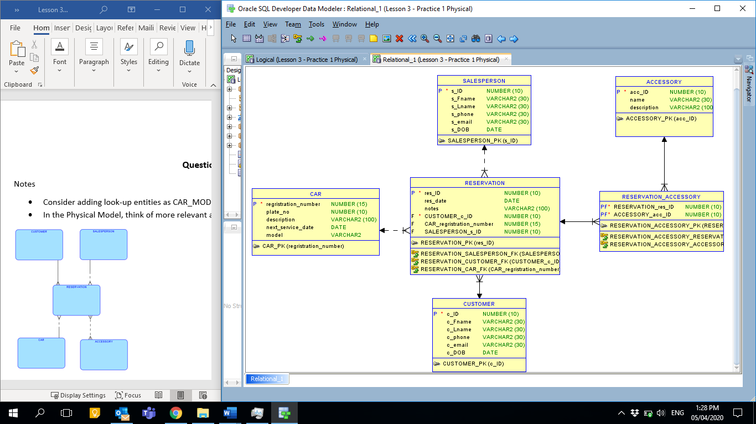

**Question 2**

Note:

* In the Physical Model, think of more relevant attributes
* Consider adding look-up entities such as MAJOR

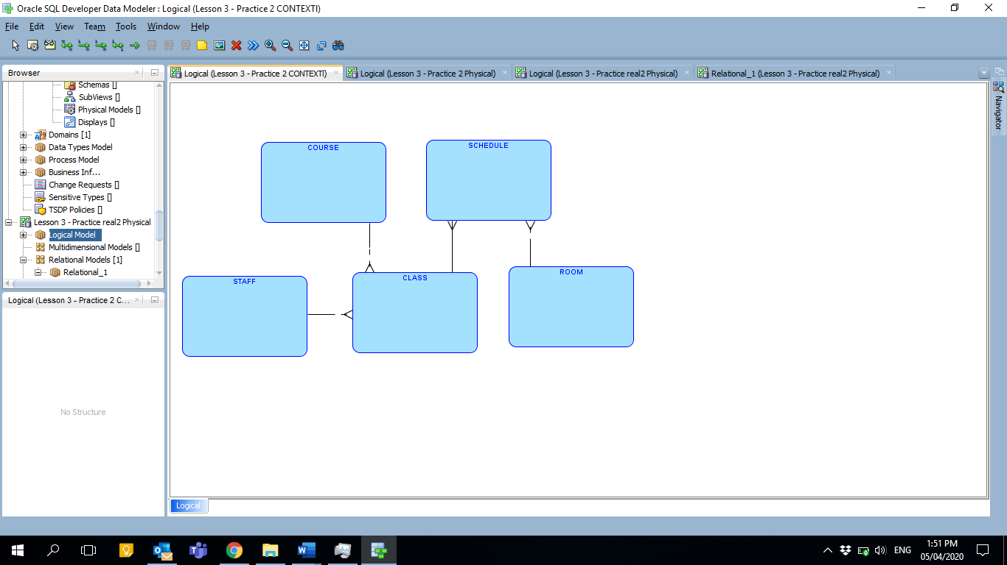

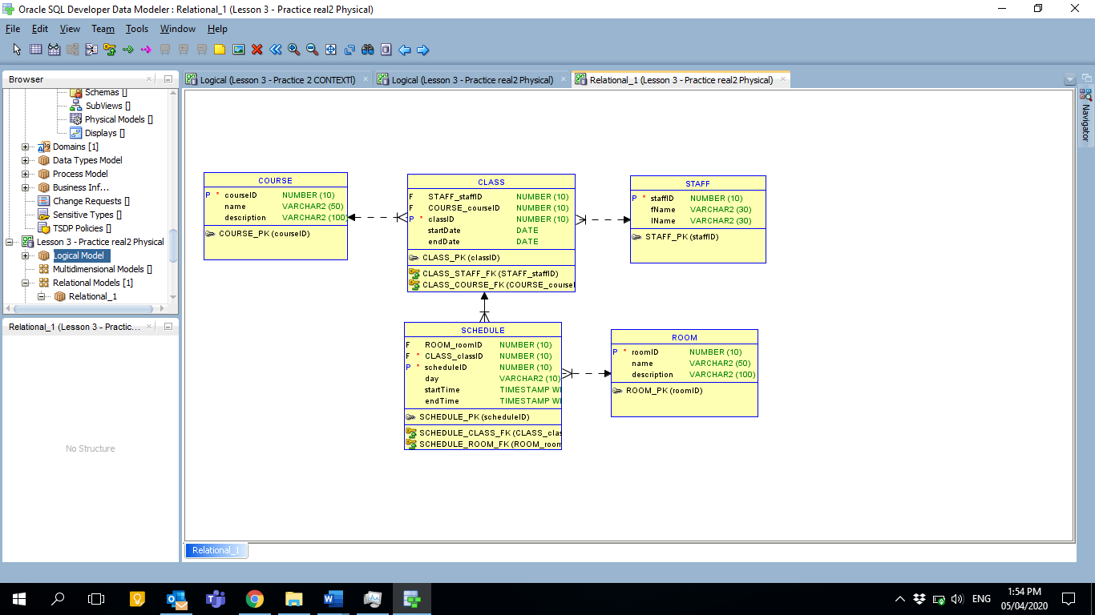

**Question 3**

Note:

* you can also have city as a separate entity with 1:1 relationship or simply add it as an attribute in team as it is not a repeating value.
* Consider adding look-up entities as SEASON. It will be connected to GAME with 1:M relationship type.
* In the Physical Model, think of more relevant attributes

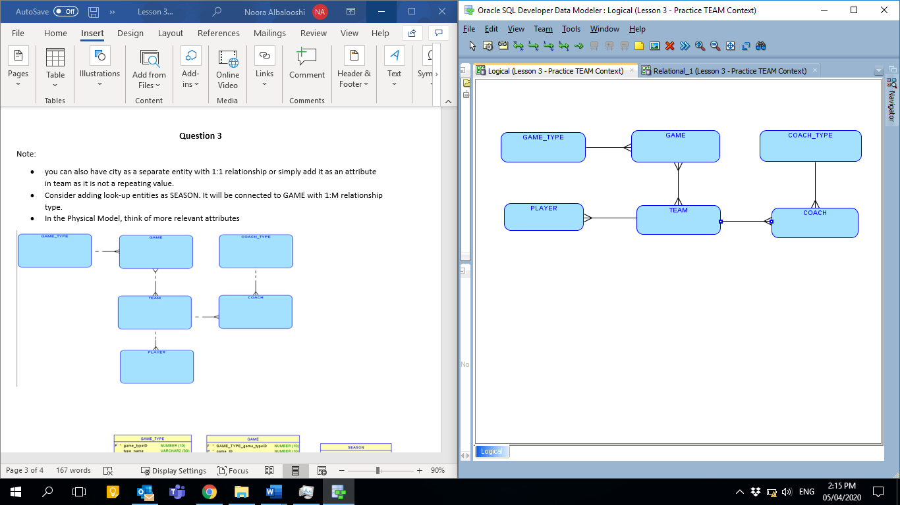

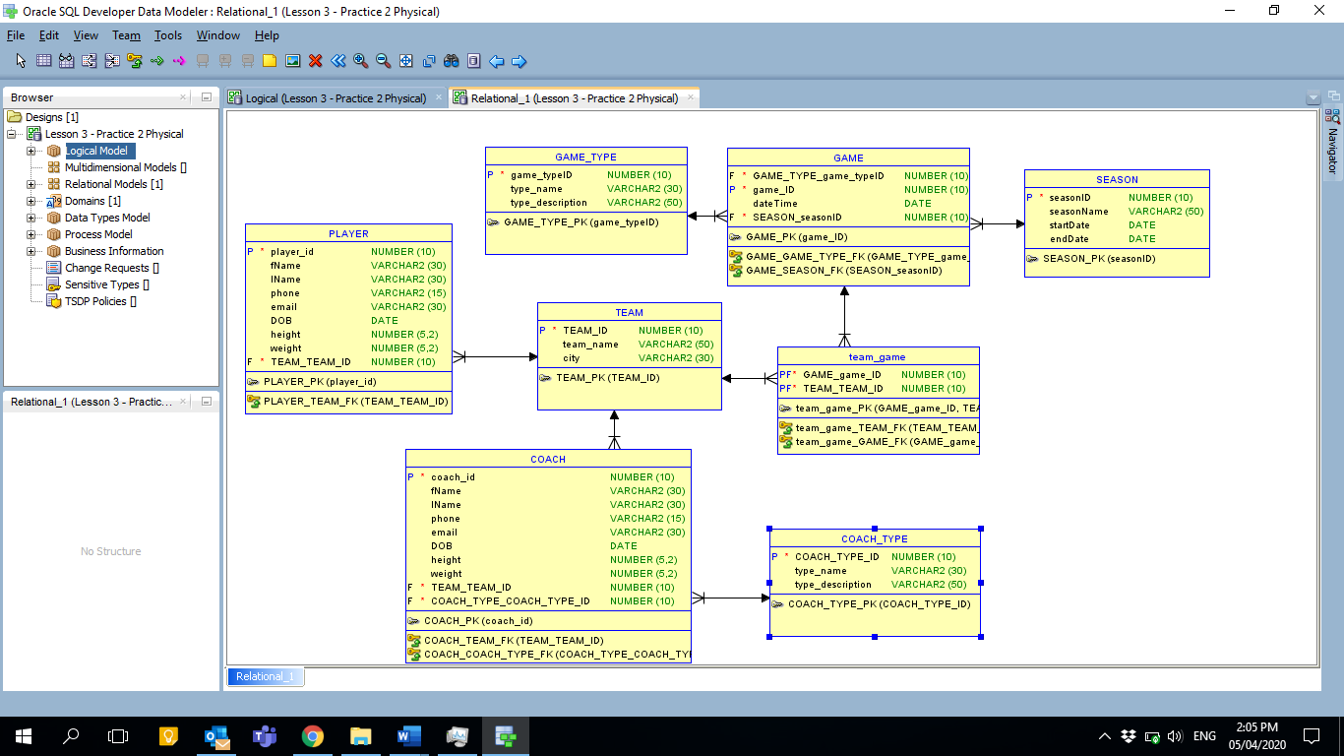

**Question 4**

Note:

* Consider adding look-up entities such as BUILDING. It will be connected to ROOM with 1:M relationship type. (You may also have a M:N relationship between ROOM and COURSE given the course is run in different rooms)
* You may also add SCHEDULE entity if you must store days and times for each class (in case of multiple classes) *see question 2*
* In the Physical Model, think of more relevant attributes

